Anti-Repost Tool for Cosplay Photos
S-02 First run (G-01 → G-02 → G-03 → G-04 → G-05 → G-07)
Edition 1 (Draft) 2026-09-29 · Ishikawa Sou
Nagareyama Software Development Co., Ltd. (NRSD)
© 2026 Nagareyama Software Development Co., Ltd. (NRSD), Lead Developer: Ishikawa Sou (石川宗). Copyright in this document belongs to Nagareyama Software Development Co., Ltd. (NRSD). Rights in the third-party standards, software, commentaries on laws, and other materials referred to in this document belong to their respective holders. This is a translation of the Japanese original; where they differ, the Japanese original prevails.
Contents
Gaps (found later and fixed)

Origin: Chapter 1, 7.1; Chapter 2, 2.1, 2.3, 2.4, 3, and 7.1; Chapter 8, 5.1 and 5.5; Chapter 10, 3.2 and 6.1; Chapter 12, 4.3.
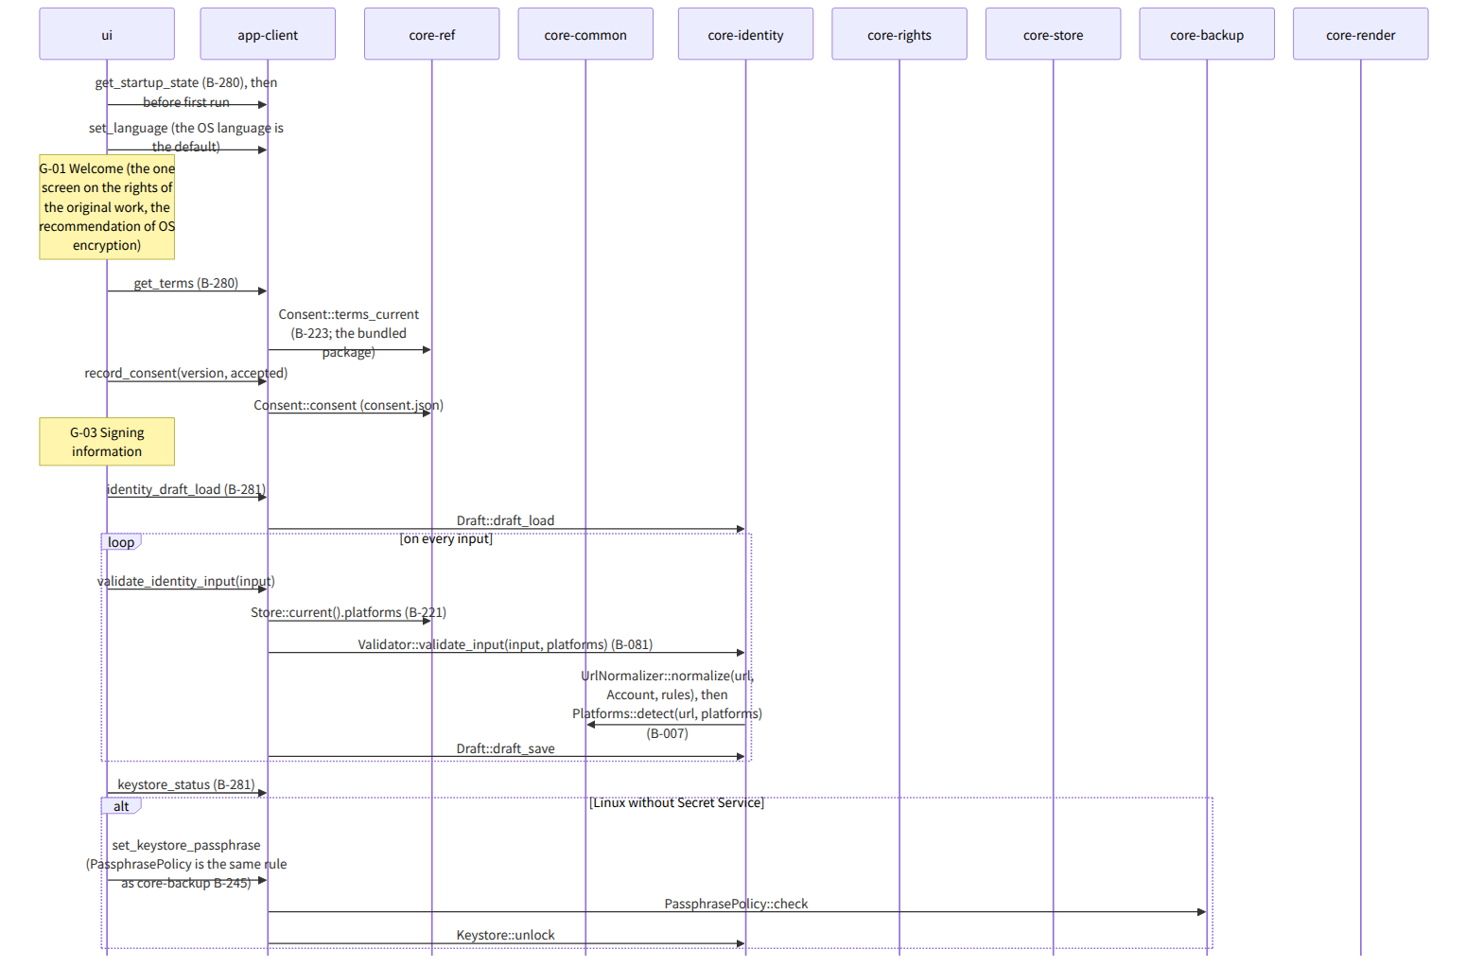
Figure：S-02 First run (G-01 → G-02 → G-03 → G-04 → G-05 → G-07)
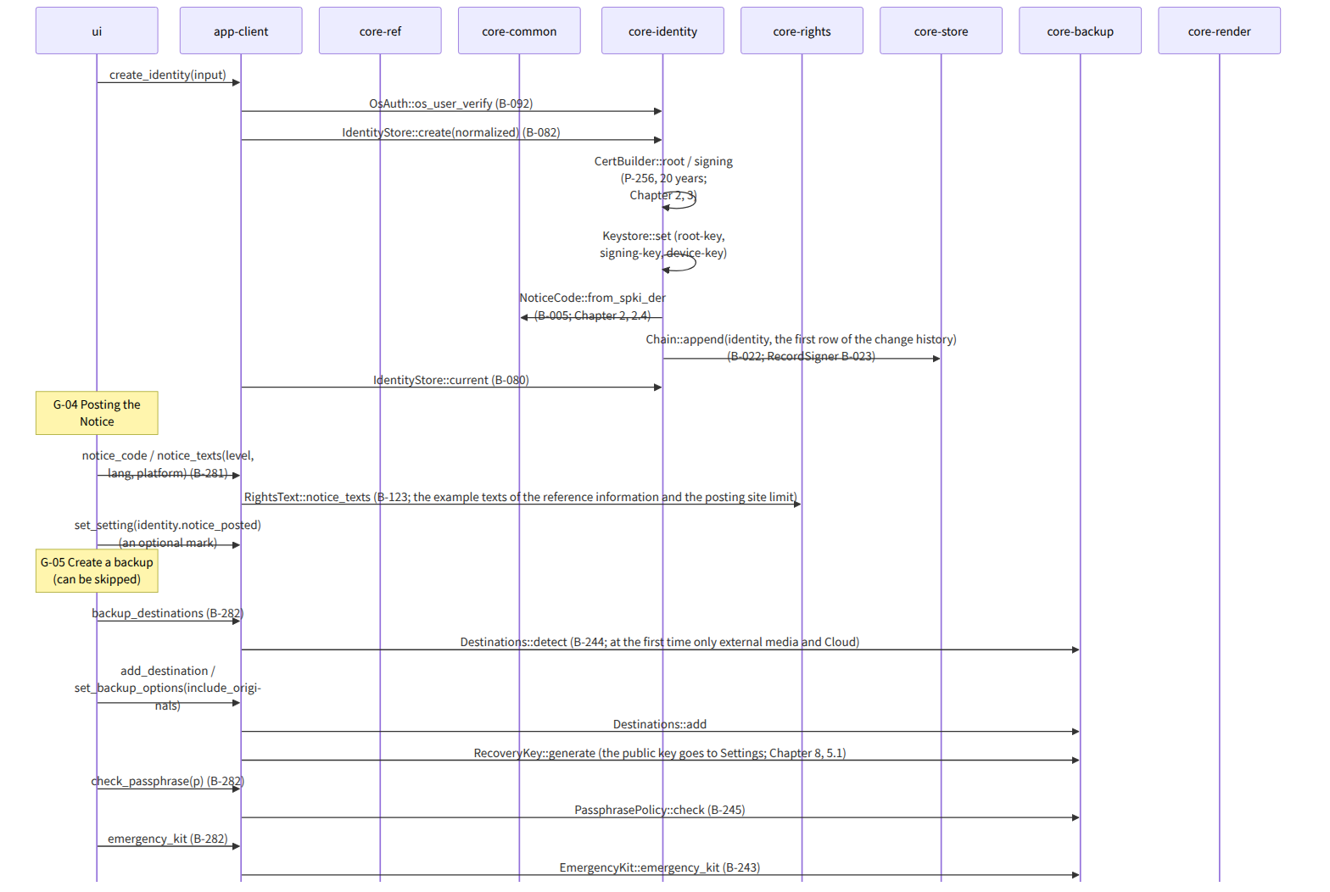
Figure：S-02 First run (G-01 → G-02 → G-03 → G-04 → G-05 → G-07)（continued 1）
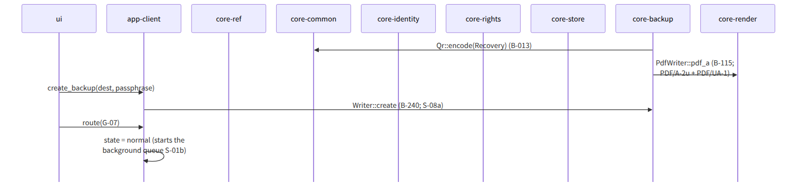
Figure：S-02 First run (G-01 → G-02 → G-03 → G-04 → G-05 → G-07)（continued 2）

Gaps (found later and fixed)
- When the recovery key is made is in Chapter 8, 5.1 (when the first backup location is decided), but core-backup's page had no “make” operation among its bridges, so, since RecoveryKey::generate is in the diagram of core-backup.md, a note was added to the bridge table B-244 of core-backup.md that the first Destinations::add of B-244 calls RecoveryKey::generate.
- The rule for the strength of the Linux keystore passphrase in the first-run G-03 is Chapter 2, 7.5 “the same as the backup passphrase”, so app-client uses core-backup's PassphrasePolicy (B-245). Because core-identity does not depend on core-backup, app-client checks the passphrase first and passes only one that passed to Keystore::unlock (one line in the dependencies of app-client.md).
- When the device key (device-key) is made was not stated in IdentityStore::create on core-identity's page, so “also makes the device key (Chapter 2, 7.1)” was added to the note of create in core-identity.md.

